**ACCURACY AVERAGE**

**1)**

Epoch 10/10 - Train Loss: 0.0202 - Train Accuracy: 98.14% - Validation Loss: 0.0167 - Validation Accuracy: 98.45%

Epoch Training Loss Training Accuracy Validation Loss \

0 1 0.511401 70.942912 0.178570

1 2 0.076605 93.906350 0.065943

2 3 0.056216 94.162925 0.050078

3 4 0.047352 95.574086 0.058899

4 5 0.033017 96.728672 0.050563

5 6 0.029206 97.370109 0.032943

6 7 0.039578 96.728672 0.062364

7 8 0.024764 97.241822 0.031466

8 9 0.010865 99.101988 0.027911

9 10 0.020160 98.139833 0.016697

Validation Accuracy

0 81.443299

1 94.845361

2 96.391753

3 93.814433

4 96.907216

5 97.422680

6 94.845361

7 96.907216

8 98.969072

9 98.453608

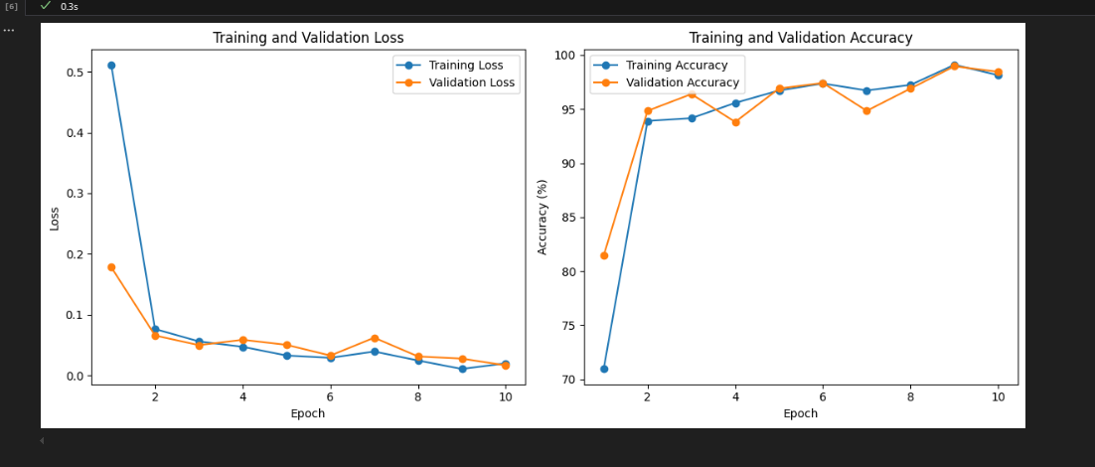

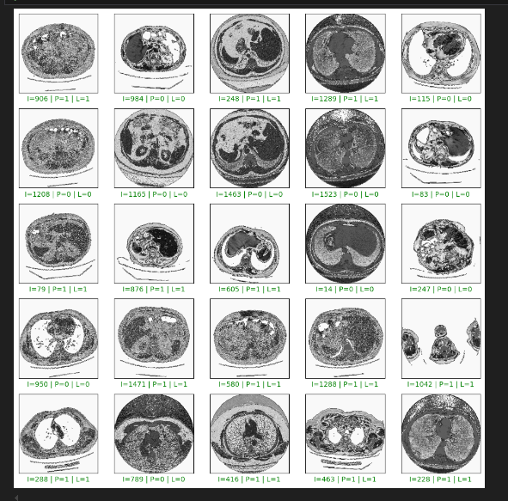

|  |  |
| --- | --- |
| PHOTOS | RESULT |
| Non Covid | Non Covid |
| Non Covid | Covid |
| Covid | Non Covid |
| Covid | Covid |
| Covid | Covid |

2)

Epoch Training Loss Training Accuracy Validation Loss \

0 1 0.550482 72.931366 0.092543

1 2 0.089390 90.635022 0.075725

2 3 0.072175 92.623477 0.068215

3 4 0.049255 94.098781 0.071300

4 5 0.047915 94.291212 0.064392

5 6 0.037467 95.638230 0.058500

6 7 0.034611 96.600385 0.057783

7 8 0.029276 97.241822 0.032447

8 9 0.040654 95.958948 0.088772

9 10 0.019167 98.652983 0.040027

Validation Accuracy

0 91.237113

1 90.206186

2 91.752577

3 95.360825

4 96.907216

5 91.237113

6 96.391753

7 95.876289

8 96.391753

9 98.453608

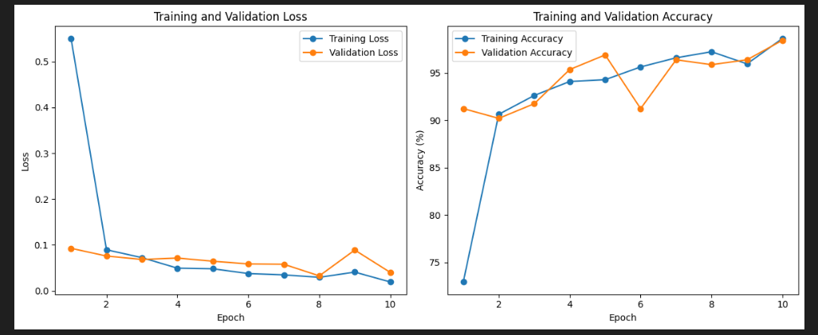

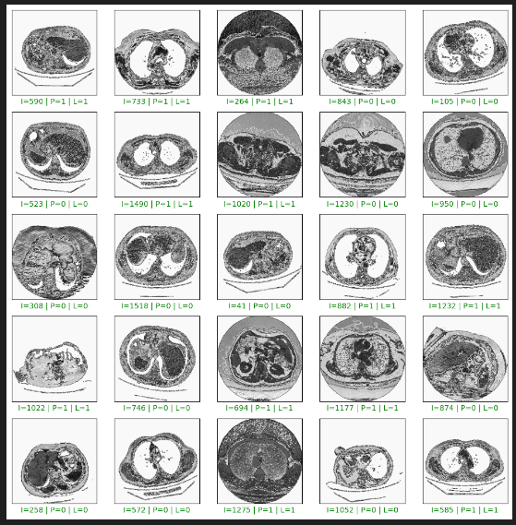

|  |  |
| --- | --- |
| PHOTO | RESULT |
| Covid | Covid |
| Covid | Covid |
| Non Covid | Covid |
| Non Covid | Non Covid |
| Non Covid | Non Covid |

**3)**

Early stopping triggered.

Epoch Training Loss Training Accuracy Validation Loss \

0 1 0.548606 77.934573 0.104432

1 2 0.089203 91.019885 0.053287

2 3 0.059472 93.457344 0.041577

3 4 0.057033 94.740218 0.115784

4 5 0.058590 93.393201 0.097169

5 6 0.048794 94.676074 0.074661

Validation Accuracy

0 90.721649

1 92.268041

2 94.329897

3 94.845361

4 94.329897

5 96.391753

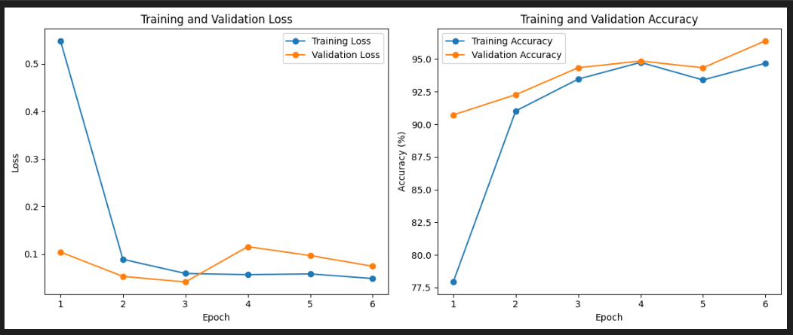

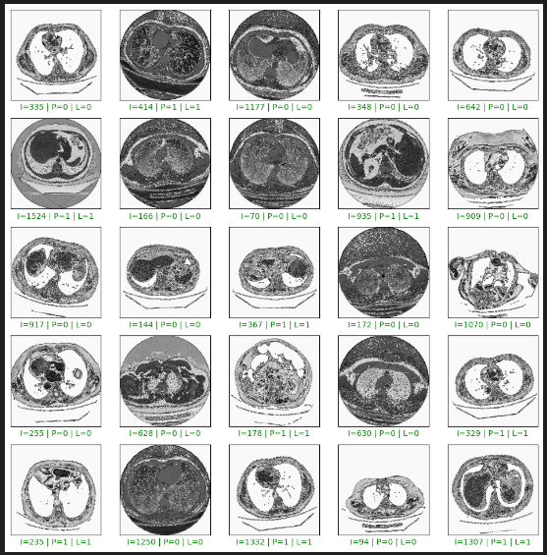

|  |  |
| --- | --- |
| PHOTOS | RESULT |
| Non Covid | Non Covid |
| Non Covid | Non Covid |
| Covid | Covid |
| Covid | Covid |
| Covid | Covid |